**The chosen Study areas for Indiana.**

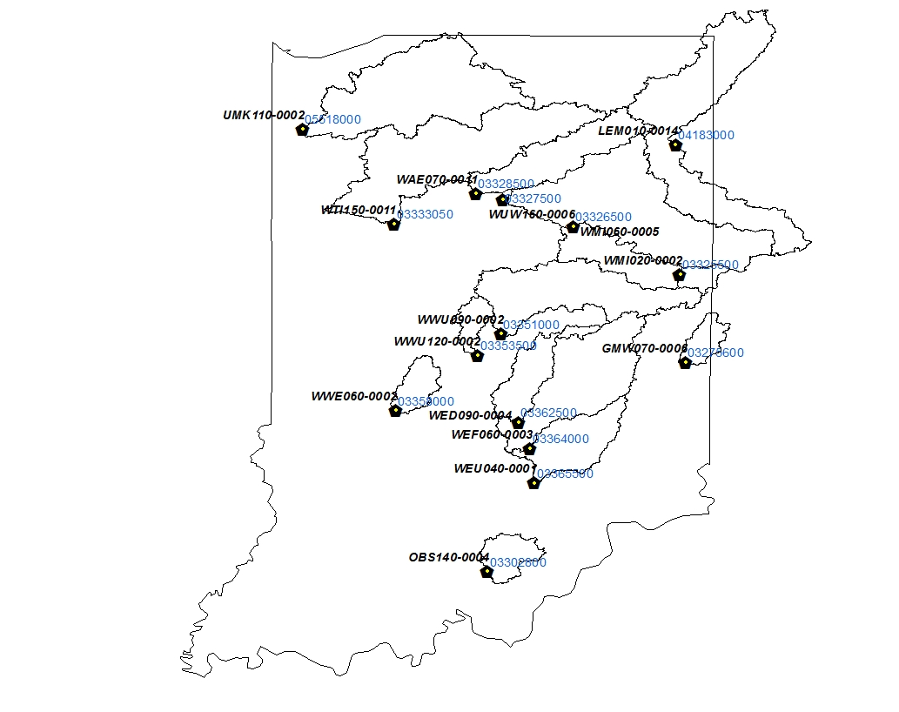

**Study areas (NLCD 2006)**

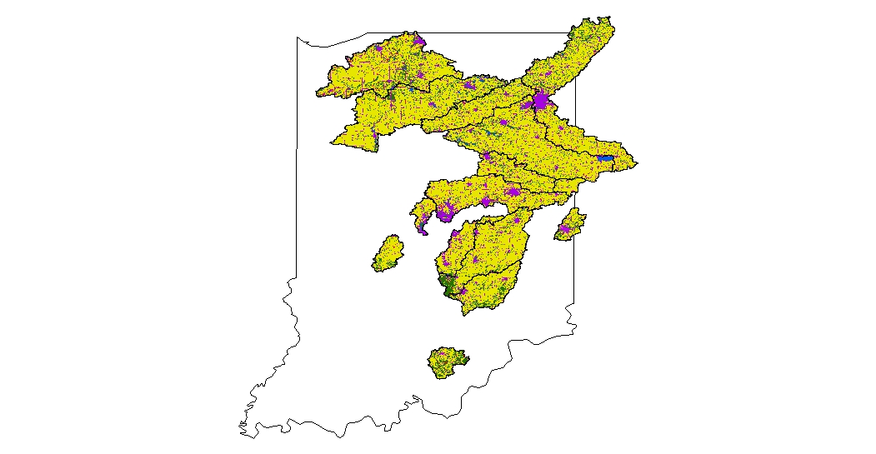

**USGS 03275600 / GMW070-0006 (N, P, and TSS) [1991 to 2012]**

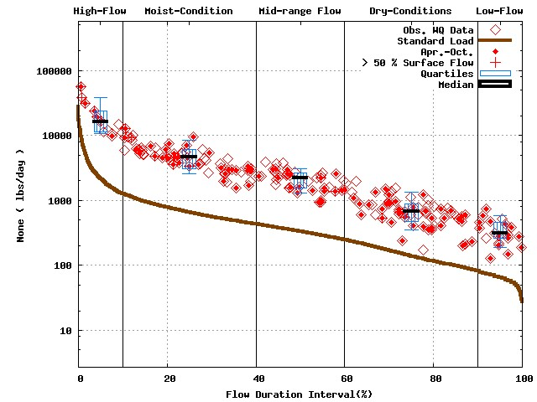 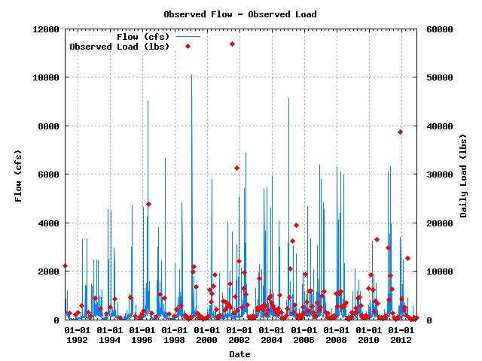

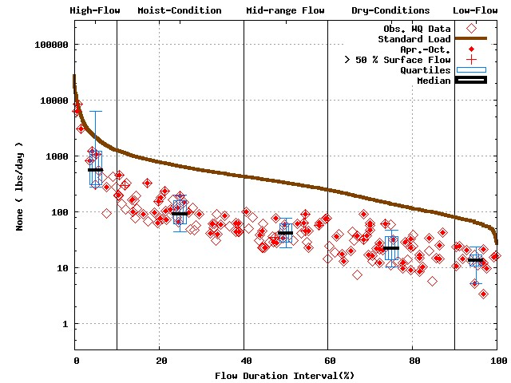 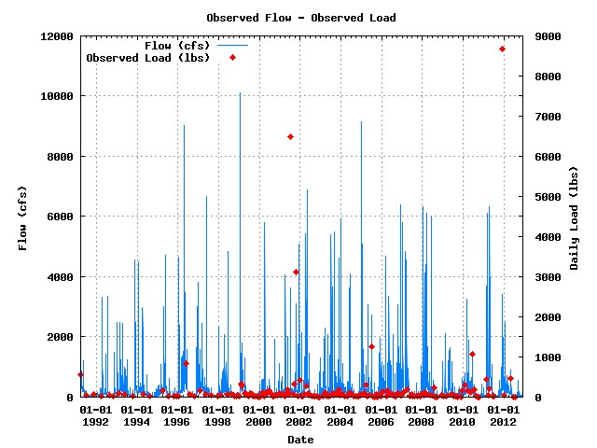

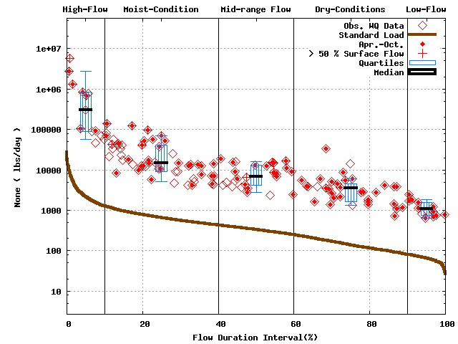 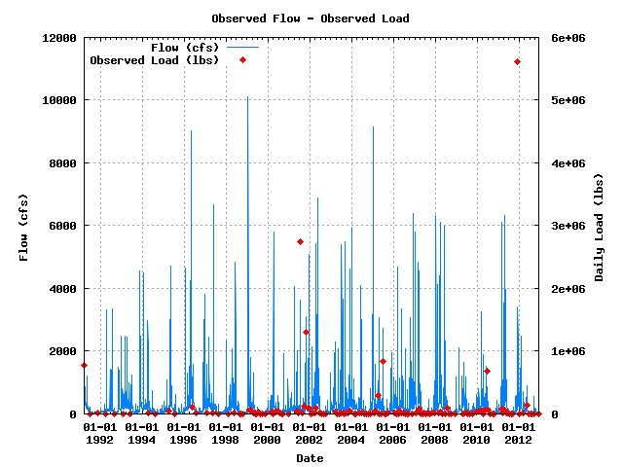

Numbers of water quality sample for Baseflow dominant flow cases 111/103/79

**USGS 03275600 / GMW070-0006 (Baseflow dominant flow plot) [1991 to 2012]**



**USGS 03302800 / OBS140-0004 (N, P, and TSS) [1991 to 2012]**

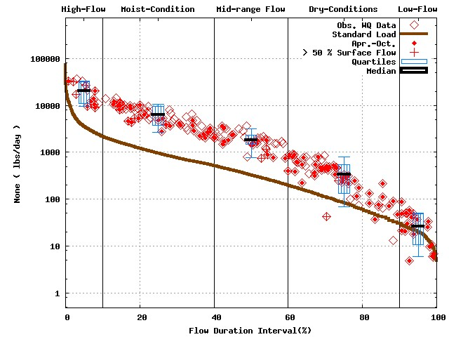 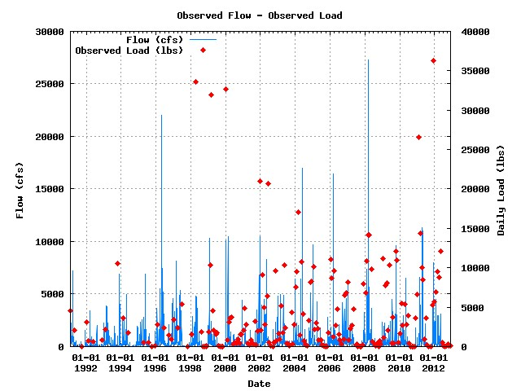

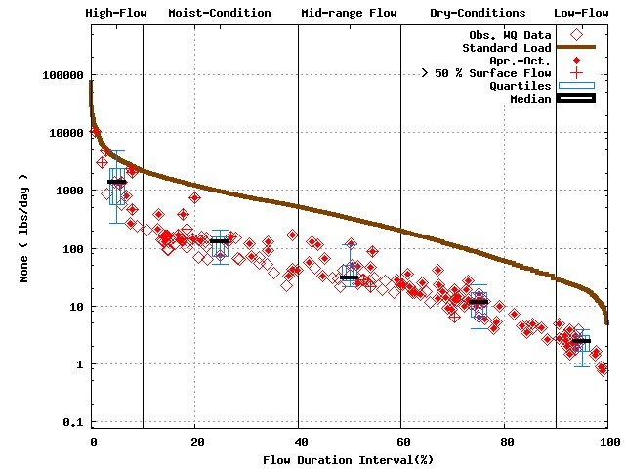 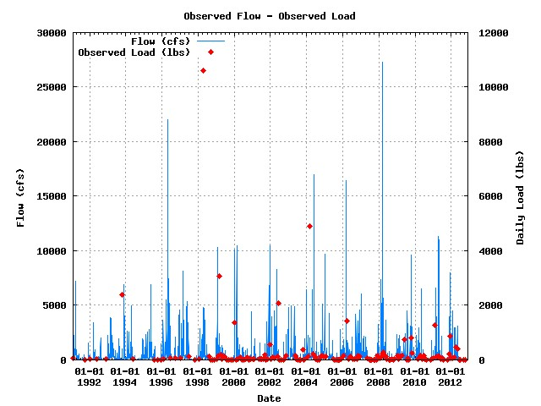

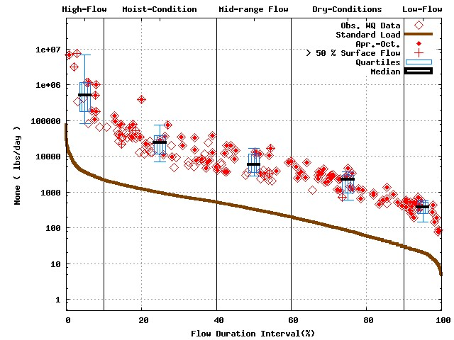 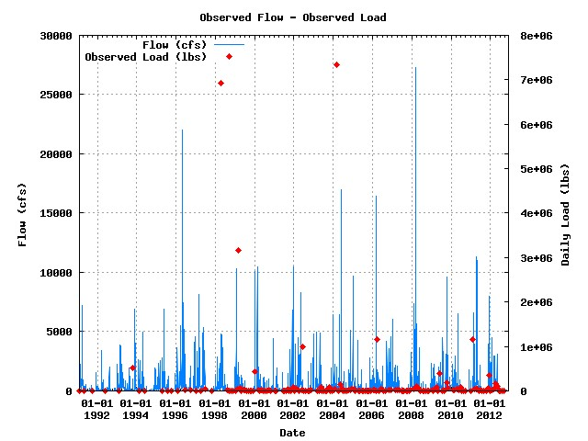

Numbers of water quality sample for Baseflow dominant flow cases 120/92/100

**USGS 03302800 / OBS140-0004 (Baseflow dominant flow plot) [1991 to 2012]**



**USGS 03325500 / WMI020-0002 (N, P, and TSS) [1991 to 2012]**

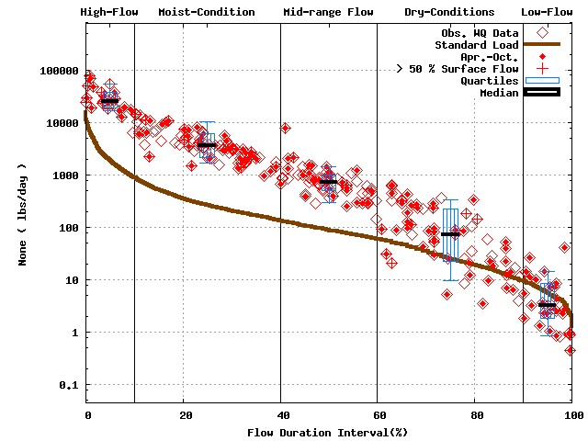 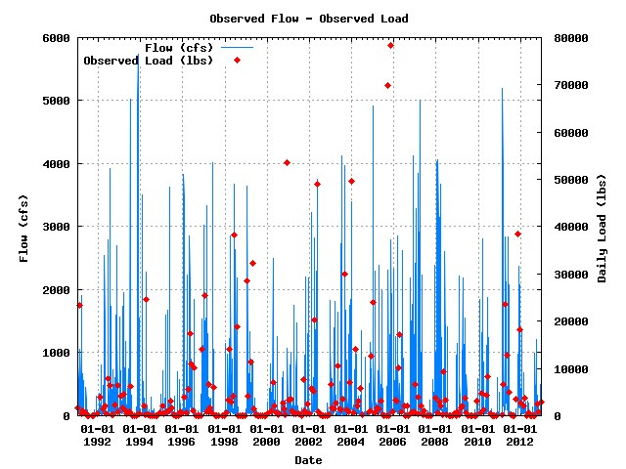

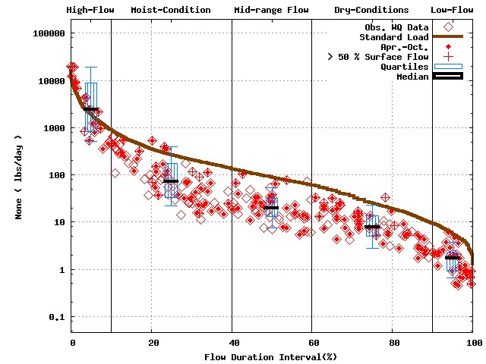 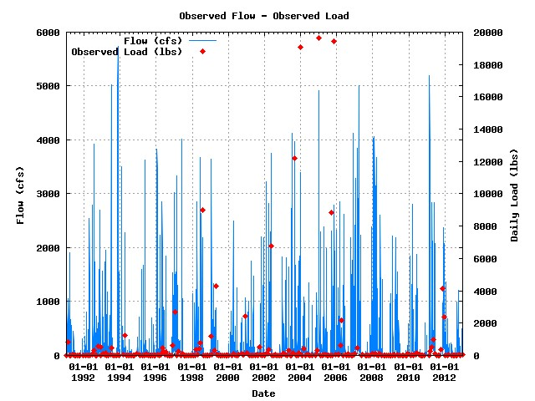

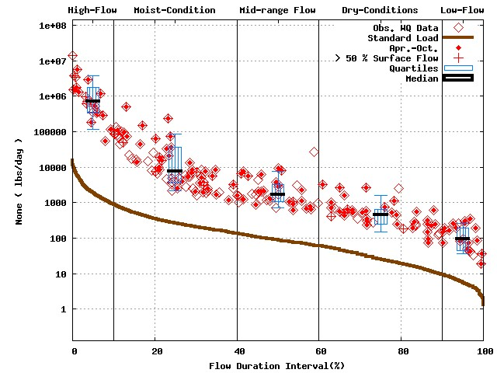 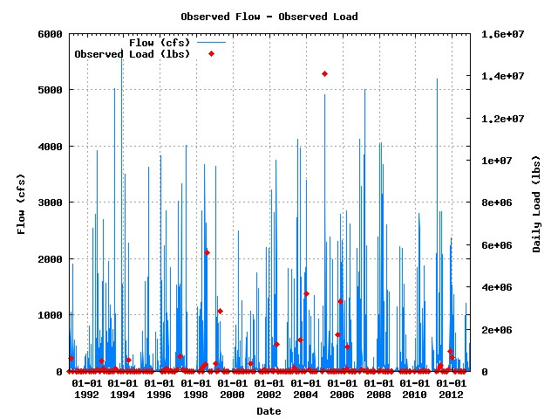

Numbers of water quality sample for Baseflow dominant flow cases 133/132/109

**USGS 03325500 / WMI020-0002 (Baseflow dominant flow plot) [1991 to 2012]**



**USGS 03326500 / WMI060-0005 (N, P, and TSS) [1991 to 2012]**

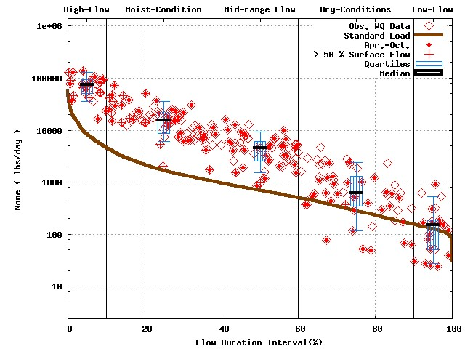 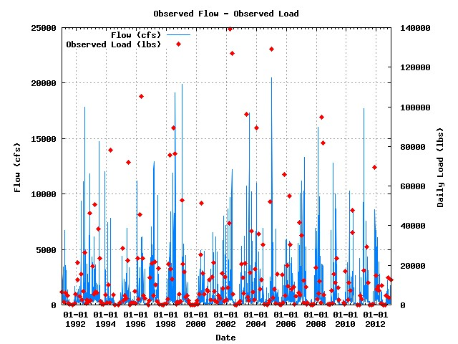

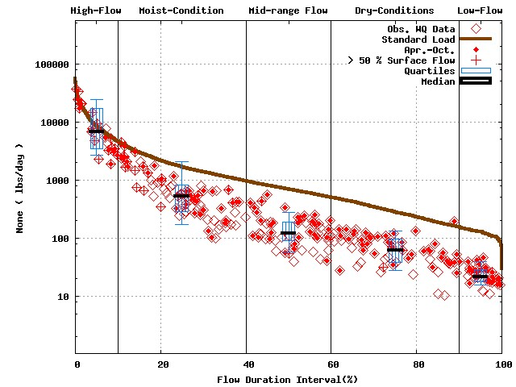 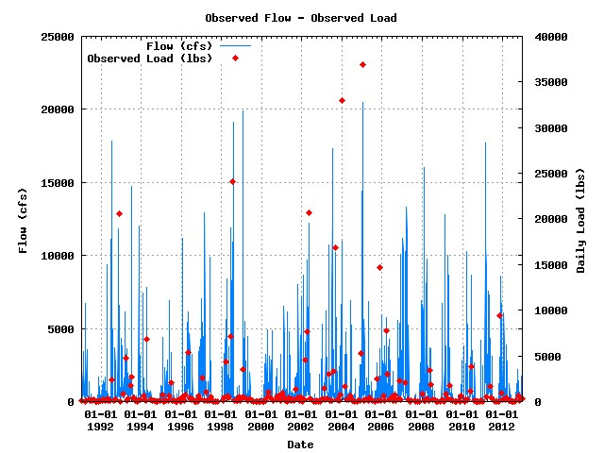

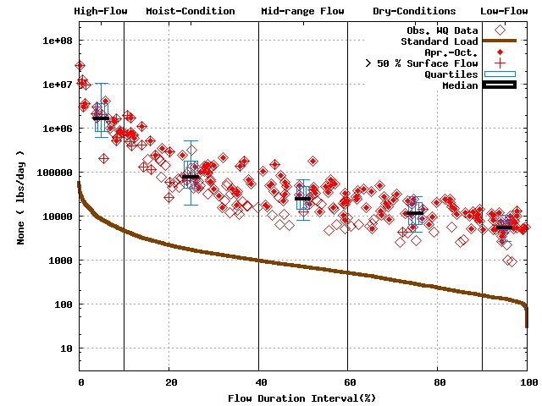 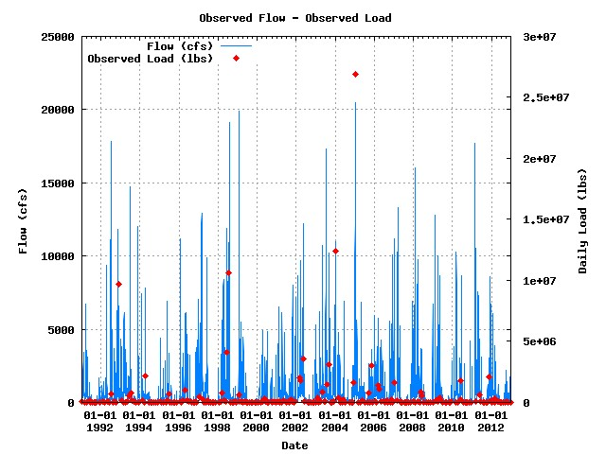

Numbers of water quality sample for Baseflow dominant flow cases 124/131/122

**USGS 03326500 / WMI060-0005 (Baseflow dominant flow plot) [1991 to 2012]**



**USGS 03327500 / WUW160-0006 (N, P, and TSS) [1991 to 2012]**

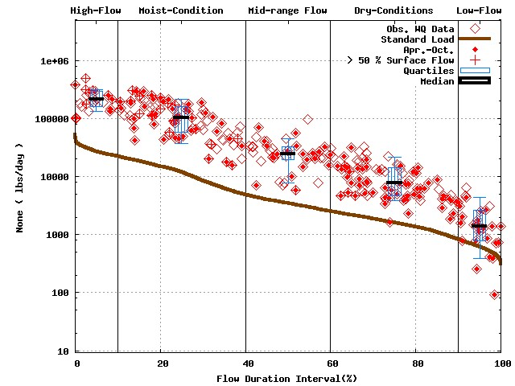 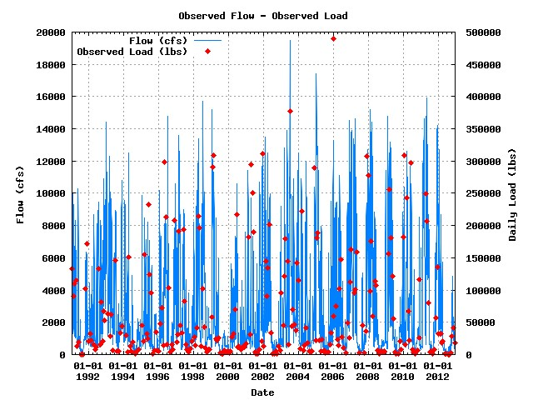

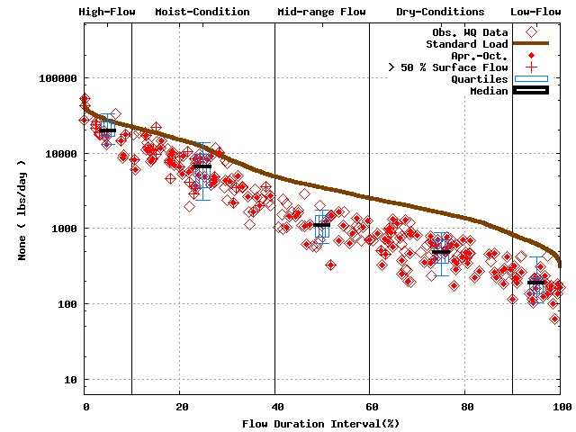 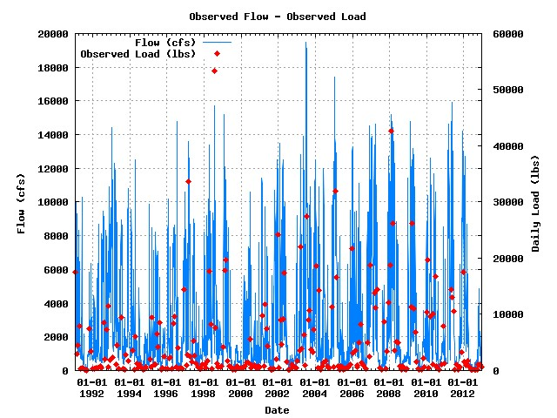

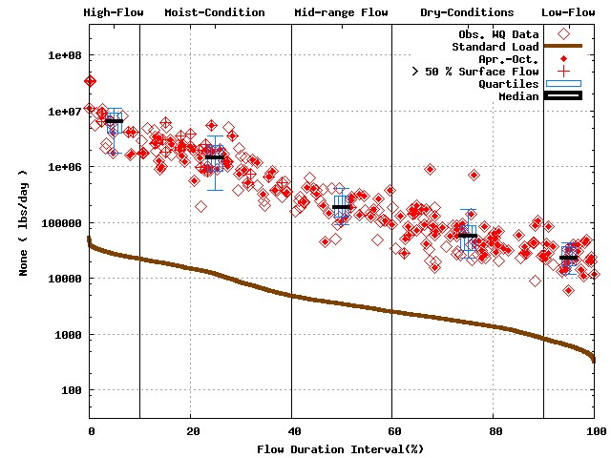 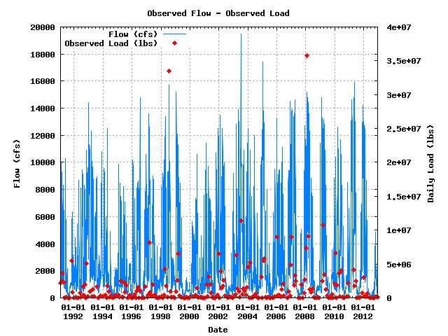

Numbers of water quality sample for Baseflow dominant flow cases 97/98/97

**USGS 03327500 / WUW160-0006 (Baseflow dominant flow plot) [1991 to 2012]**



**USGS 03328500 / WAE070-0011 (N, P, and TSS) [1991 to 2012]**

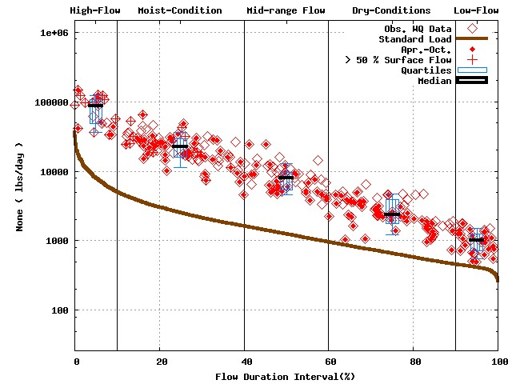 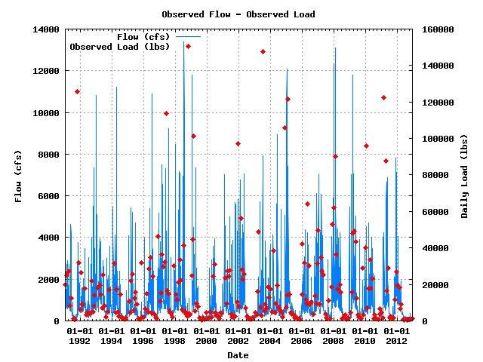

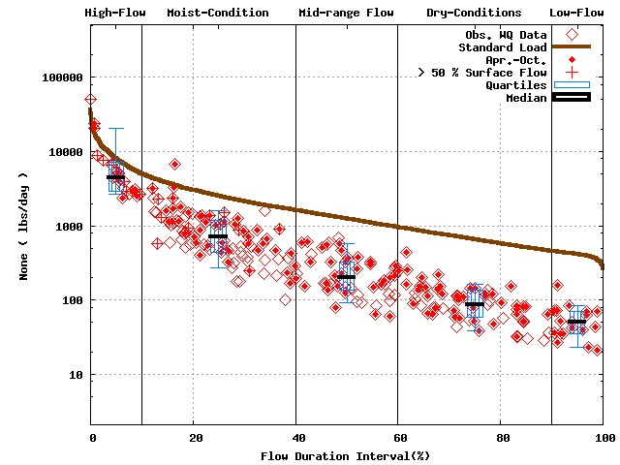 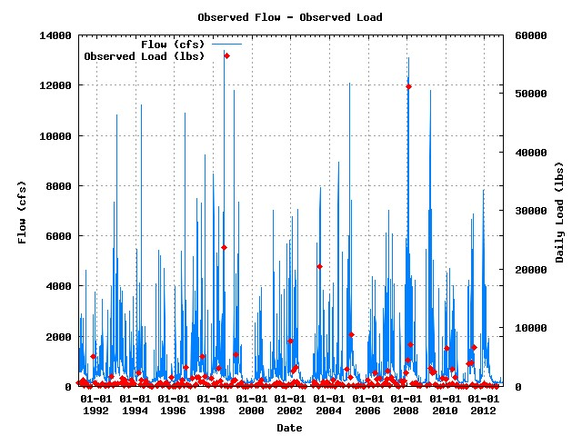

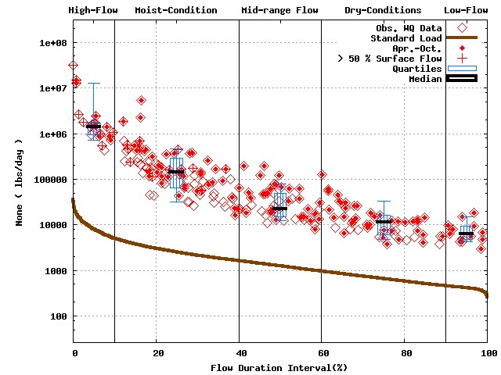 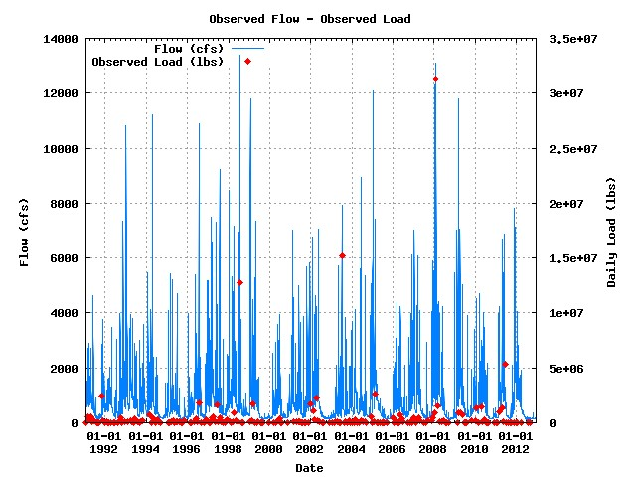

Numbers of water quality sample for Baseflow dominant flow cases 134/131/123

**USGS 03328500 / WAE070-0011 (Baseflow dominant flow plot) [1991 to 2012]**



**USGS 03333050 / WTI150-0011 (N, P, and TSS) [1991 to 2012]**

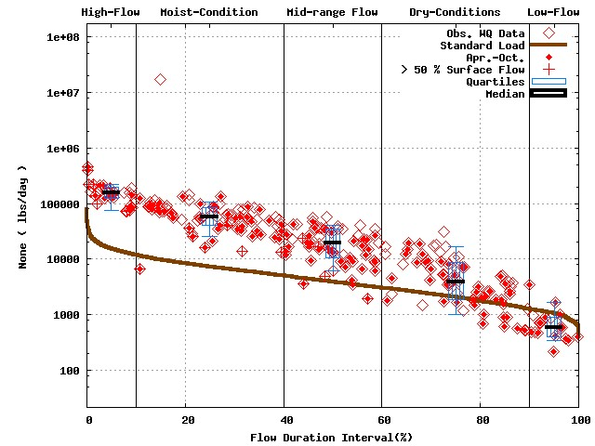 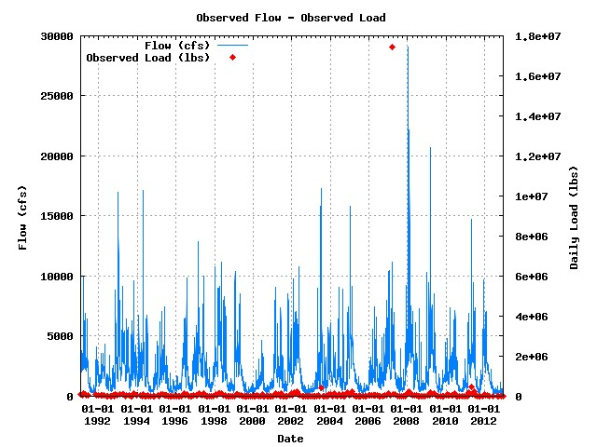

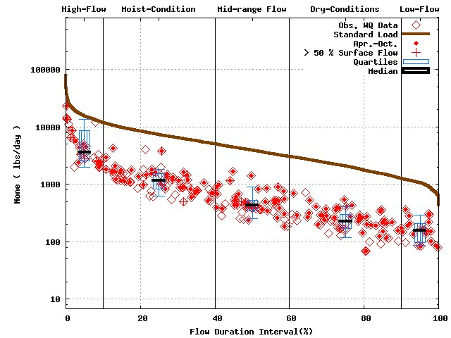 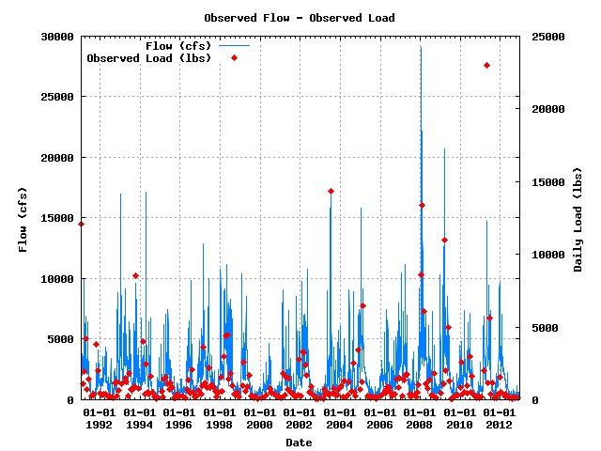

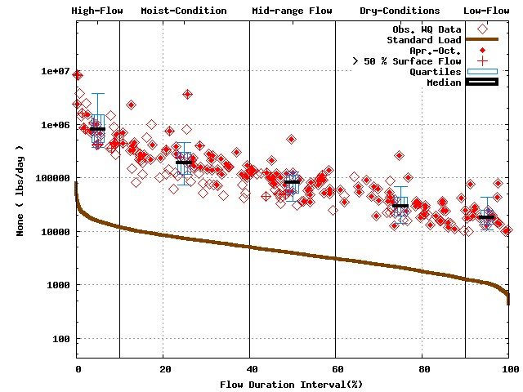 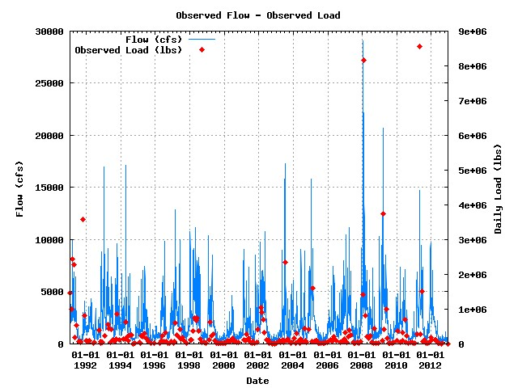

Numbers of water quality sample for Baseflow dominant flow cases 81/82/76

**USGS 03333050 / WTI150-0011 (Baseflow dominant flow plot) [1991 to 2012]**



**USGS 03351000 / WWU090-0002 (N, P, and TSS) [1991 to 2012]**

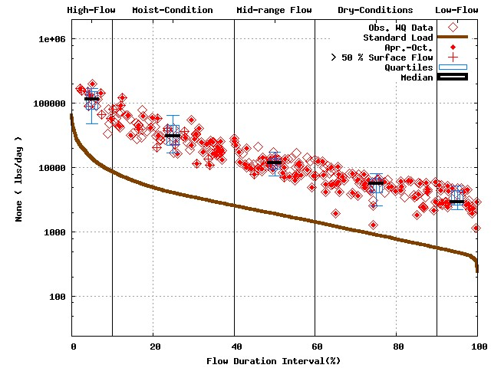 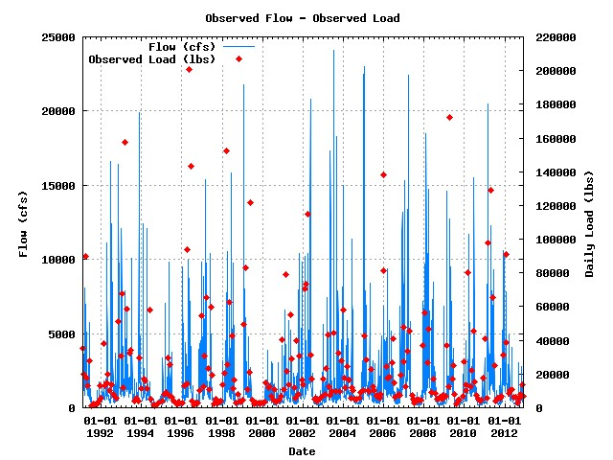

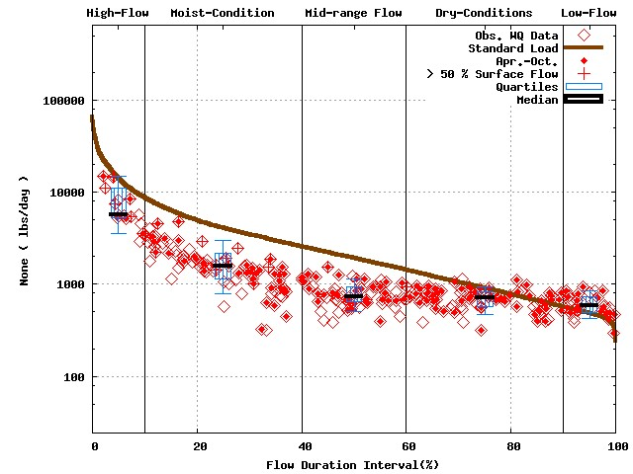 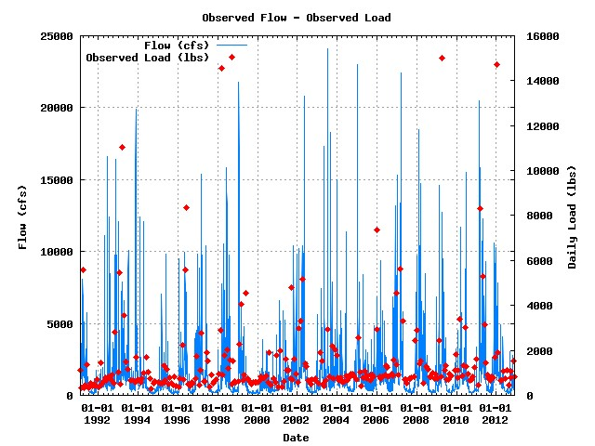

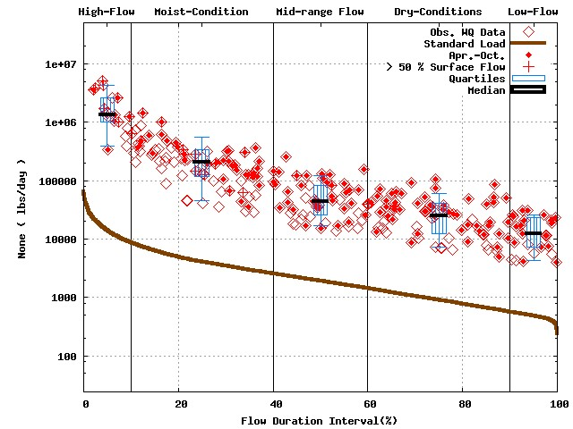 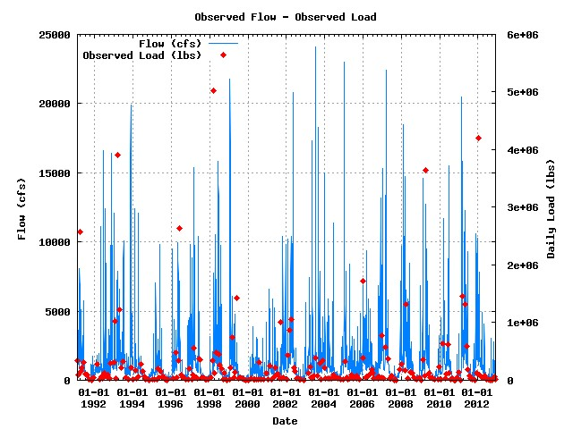

Numbers of water quality sample for Baseflow dominant flow cases 137/137/131

**USGS 03351000 / WWU090-0002 (Baseflow dominant flow plot) [1991 to 2012]**



**USGS 03353500 / WWU120-0002 (N, P, and TSS) [1991 to 2012]**

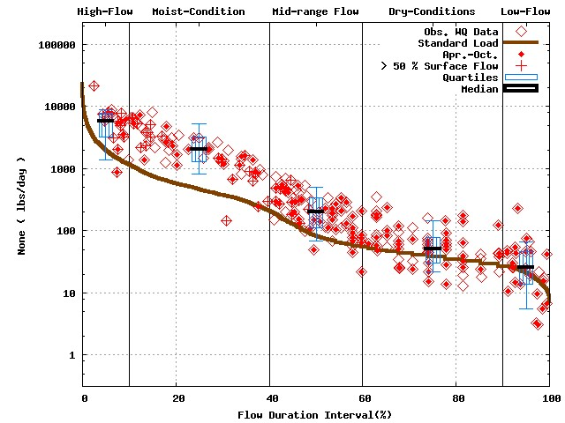 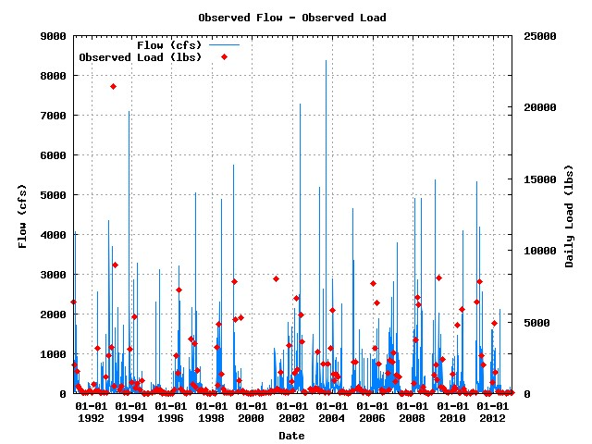

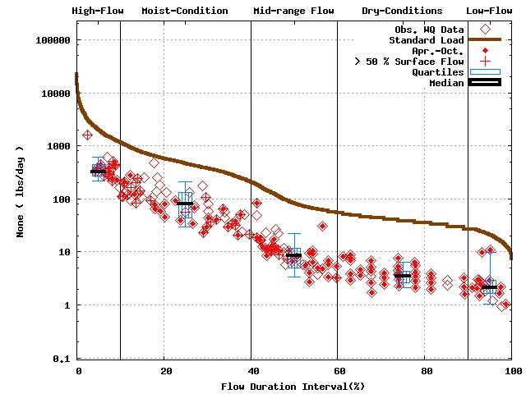 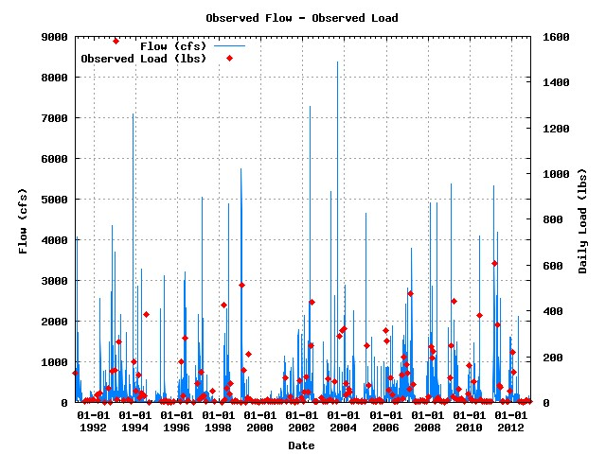

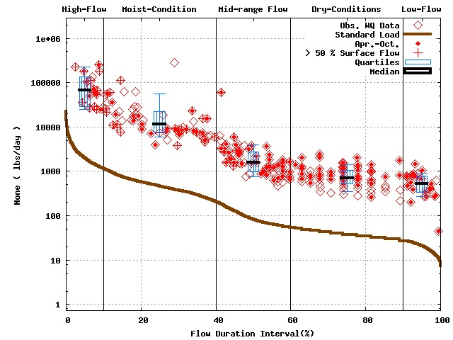 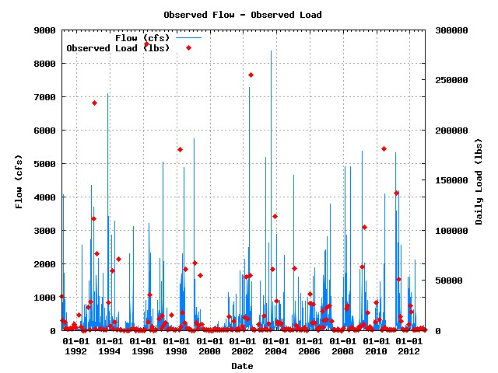

Numbers of water quality sample for Baseflow dominant flow cases 116/95/108

**USGS 03353500 / WWU120-0002 (Baseflow dominant flow plot) [1991 to 2012]**



**USGS 03358000 / WWE060-0002 (N, P, and TSS) [1991 to 2012]**

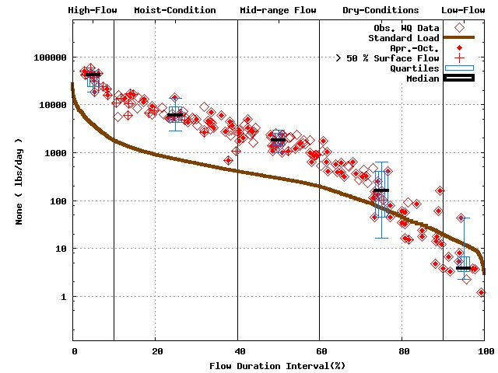 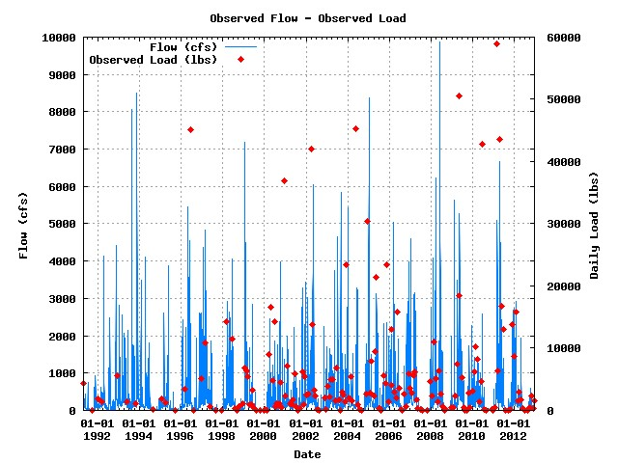

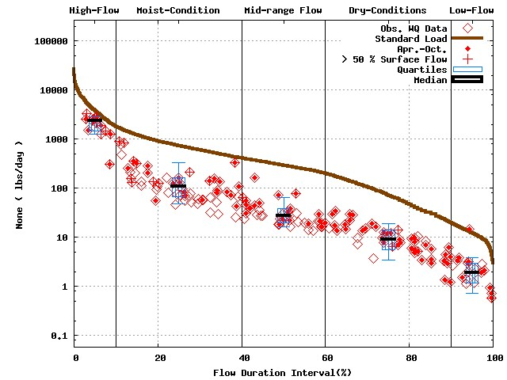 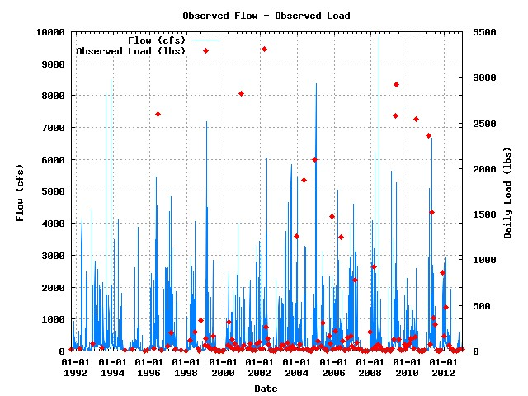

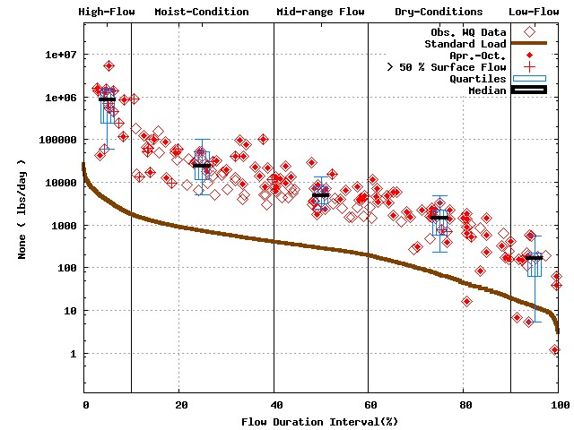 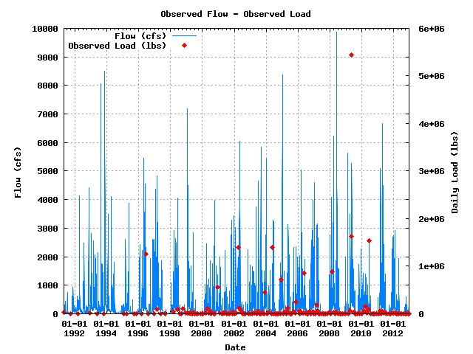

Numbers of water quality sample for Baseflow dominant flow cases 110/108/108

**USGS 03358000 / WWE060-0002 (Baseflow dominant flow plot) [1991 to 2012]**



**USGS 03362500 / WED090-0004 (N, P, and TSS) [1991 to 2012]**

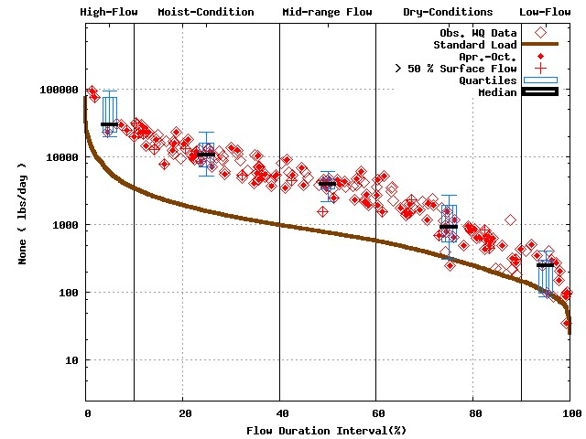 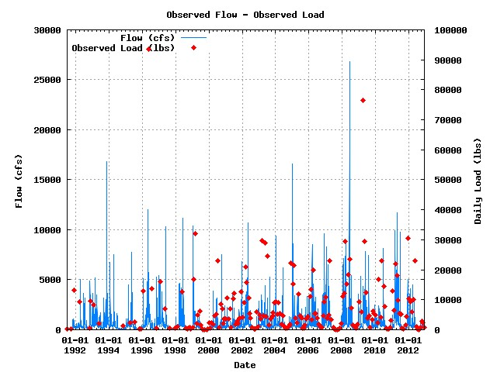

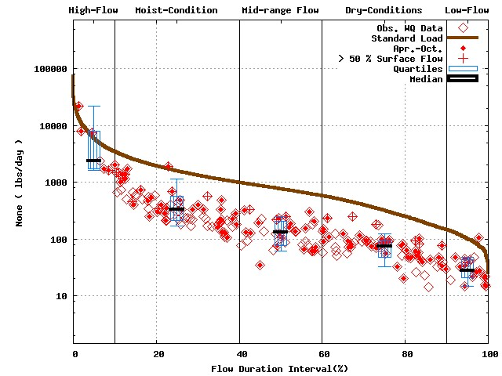 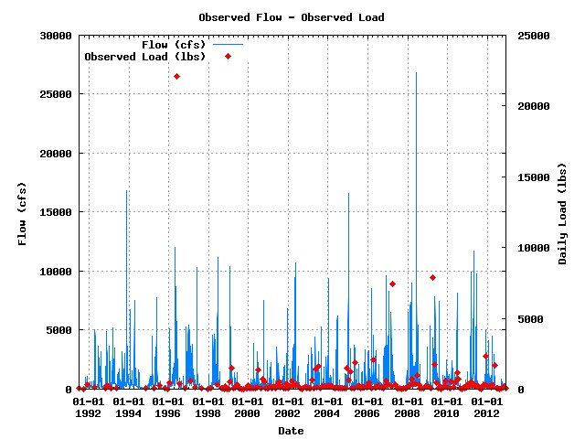

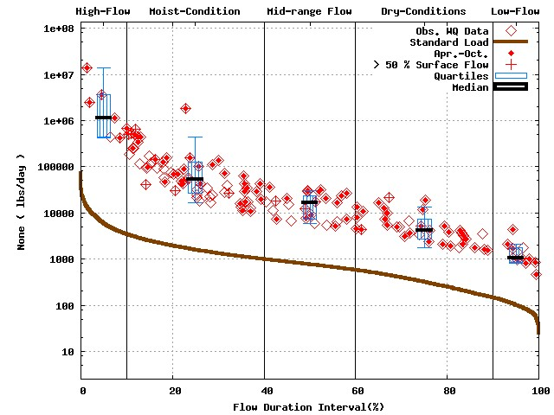 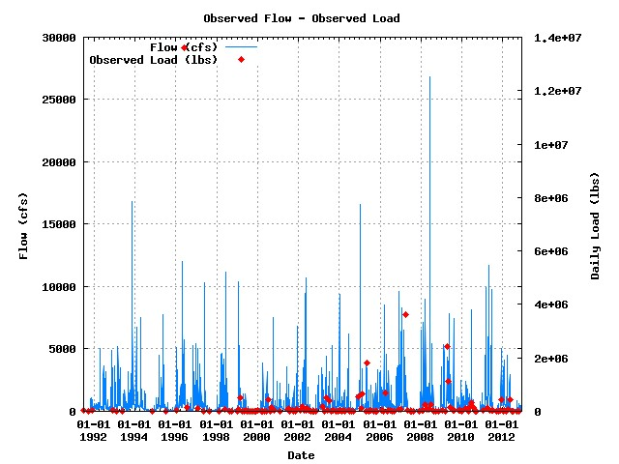

Numbers of water quality sample for Baseflow dominant flow cases 101/100/79

**USGS 03362500 / WED090-0004 (Baseflow dominant flow plot) [1991 to 2012]**



**USGS 03364000 / WEF060-0003 (N, P, and TSS) [1991 to 2012]**

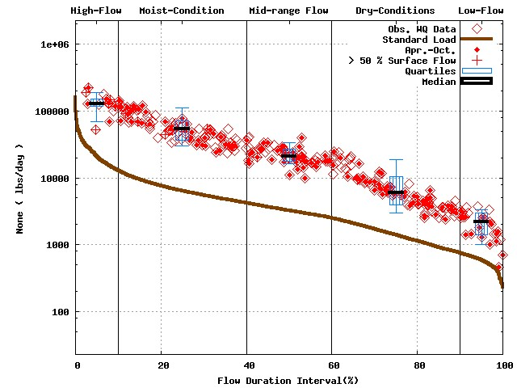 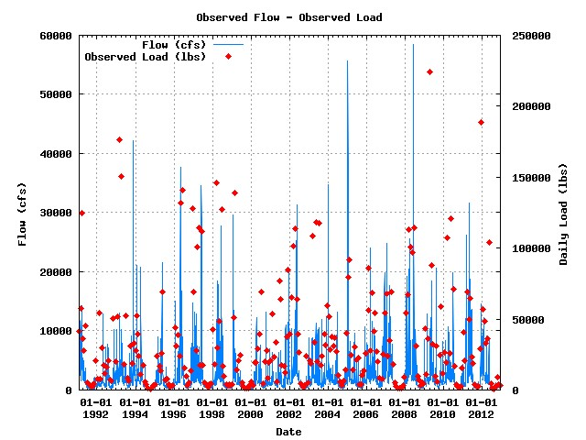

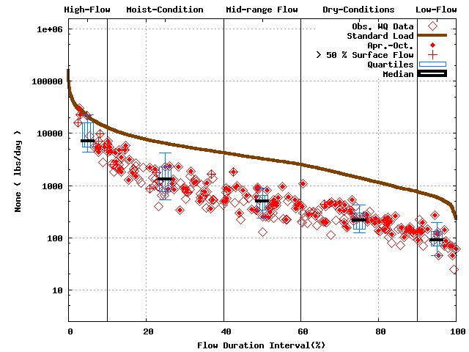 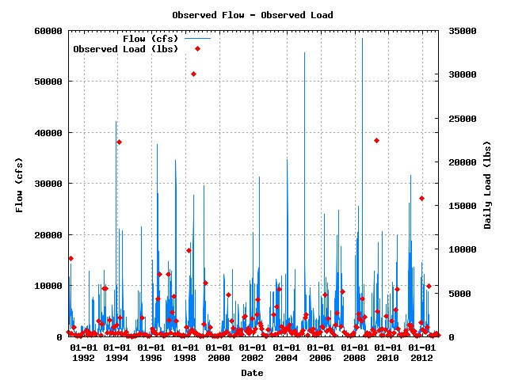

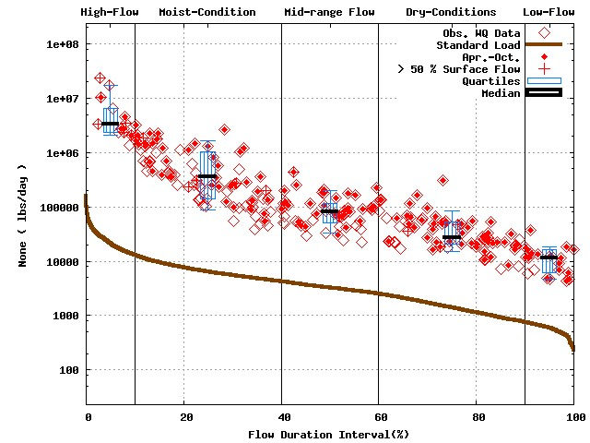 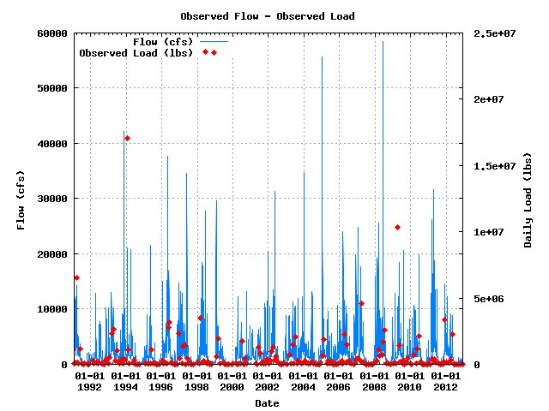

Numbers of water quality sample for Baseflow dominant flow cases 141/133/124

**USGS 03364000 / WEF060-0003 (Baseflow dominant flow plot) [1991 to 2012]**



**USGS 03365500 / WEU040-0001 (N, P, and TSS) [1991 to 2012]**

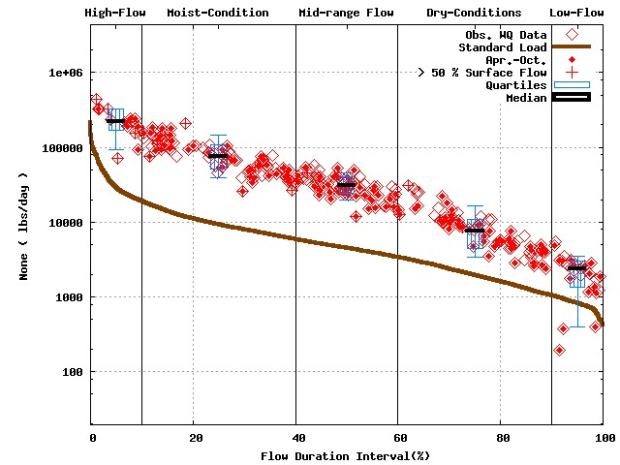 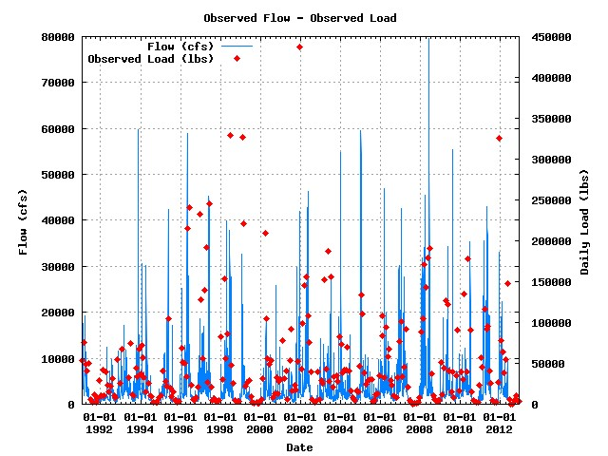

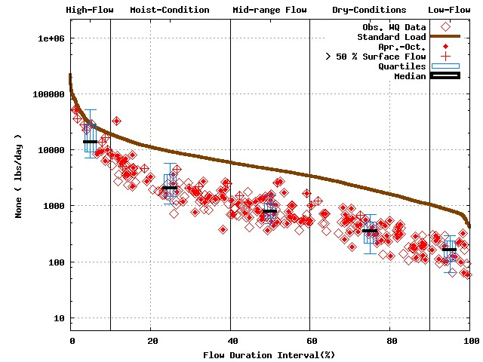 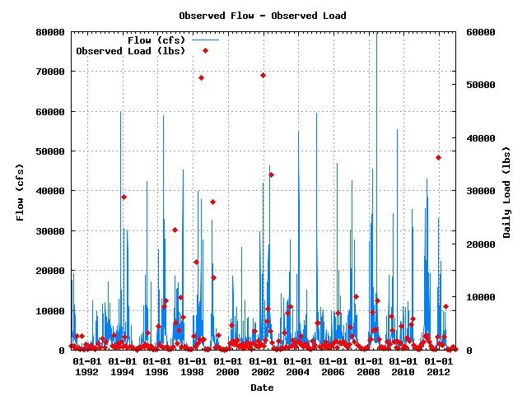

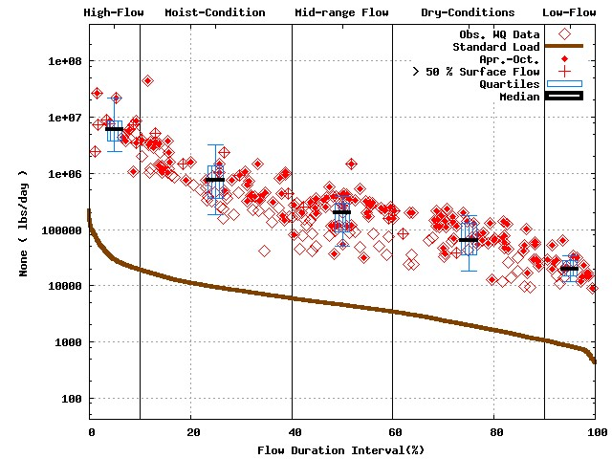 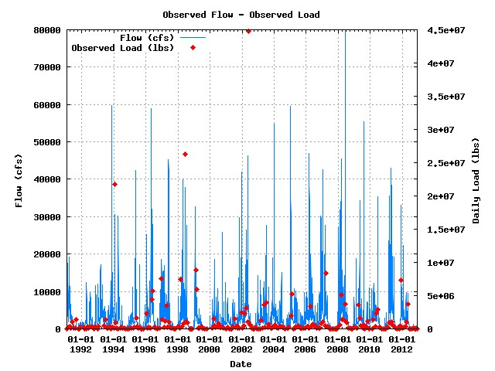

Numbers of water quality sample for Baseflow dominant flow cases 144/142/137

**USGS 03365500 / WEU040-0001 (Baseflow dominant flow plot) [1991 to 2012]**



**USGS 04183000 / LEM010-0014 (N, P, and TSS) [1991 to 2012]**

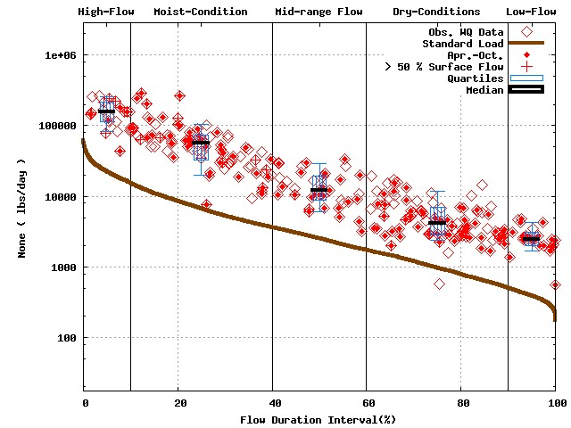 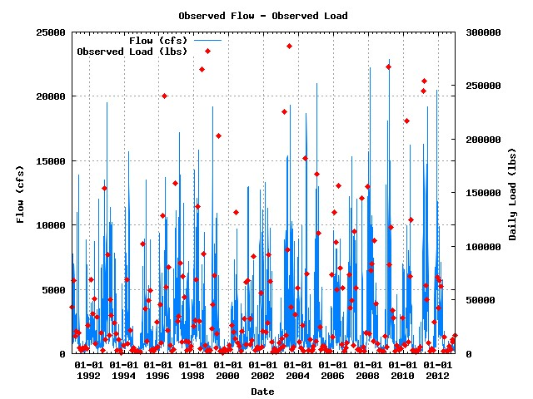

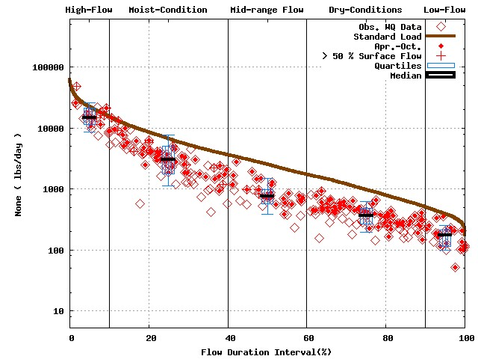 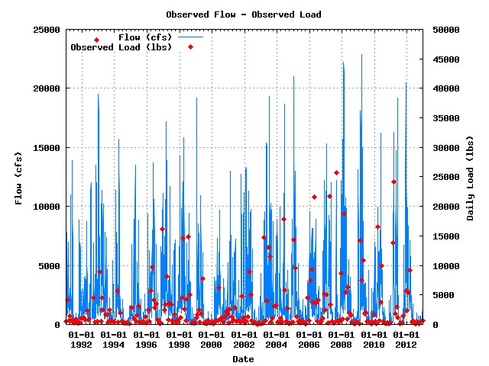

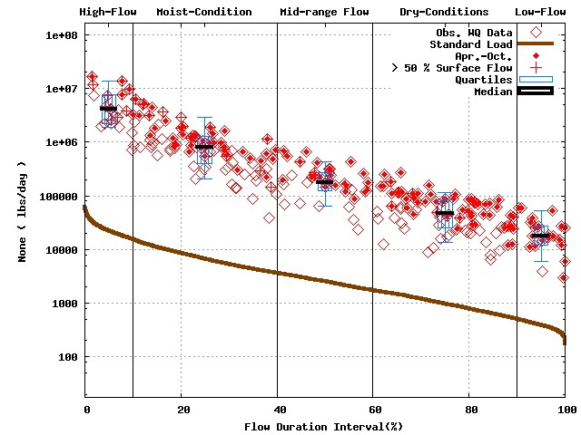 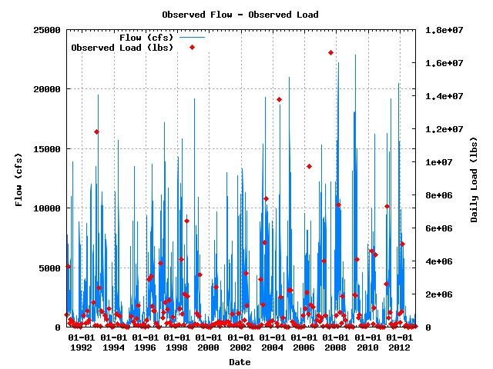

Numbers of water quality sample for Baseflow dominant flow cases 114/114/110

**USGS 04183000 / LEM010-0014 (Baseflow dominant flow plot) [1991 to 2012]**



**USGS 05518000 / UMK110-0002 (N, P, and TSS) [1991 to 2012]**

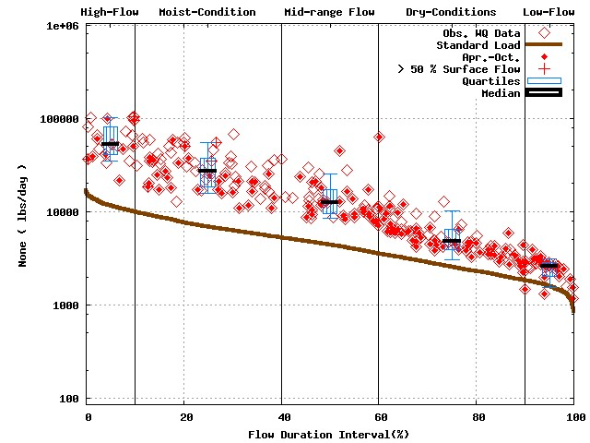 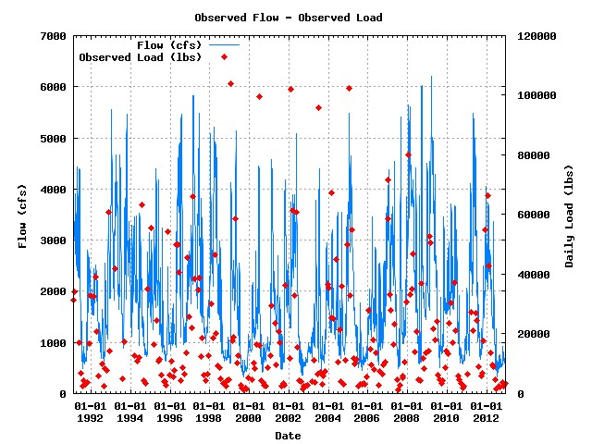

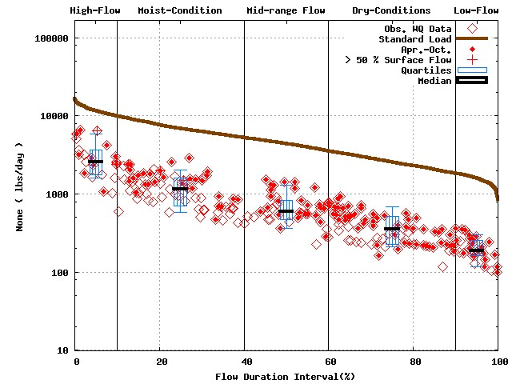 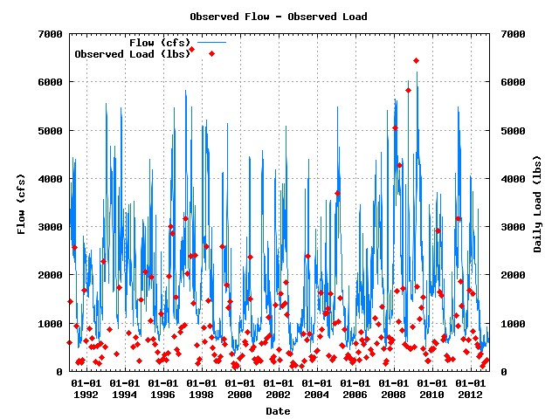

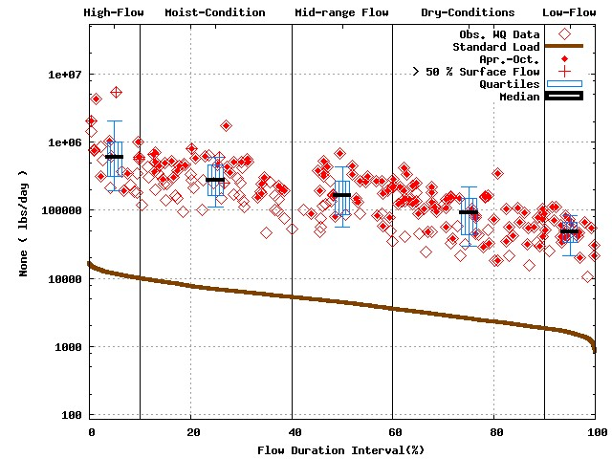 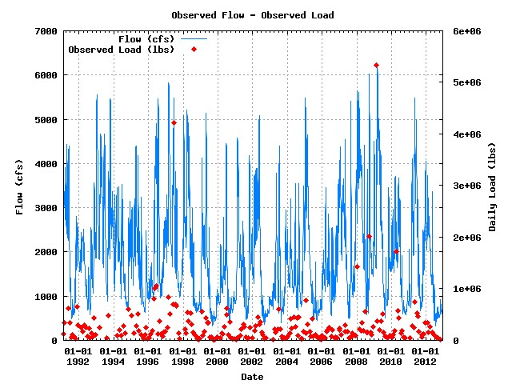

Numbers of water quality sample for Baseflow dominant flow cases 66/65/65

**USGS 05518000 / UMK110-0002 (Baseflow dominant flow plot) [1991 to 2012]**

